

Department of Computer Engineering & Technology

CSE-AIDS --- LEVEL 1

Capstone Project Synopsis 2026-27

Group No: | Students names | PRN | Email, Mobile number | Panel | Sign of student
 | Mrinmayee Gokhale | 1032232136 | mrinmayee.gokhale@mitwpu.edu.in  9930043925 | A
 | Hritvi Bhole | 1032231780 | hritvi.bhole@mitwpu.edu.in  9167638656 | A
 | Samay Gandhi | 1032232197 | samay.gandhi@mitwpu.edu.in  9503631008 | A

Project Title:

Active Verification:
An Agentic Multi-Domain Framework for LLM-Generated Phishing

Project Domain:
Primary Domain: Cybersecurity
Tech Domain:
- Agentic AI
- Large Language Models
- Natural Language Processing (NLP)
- Explainable AI (XAI)
- Machine Learning / Deep Learning
- Generative AI
- Human-Computer Interaction (for the dashboard/evidence-trail component)
- Web Security (given the email + website dual-domain scope)

INHOUSE PROJECT: YES

Abstract:

The emergence of Large Language Models has significantly altered the phishing threat landscape: attackers can now generate linguistically coherent, contextually adaptive content at scale, which undermines classifiers trained on the stylistic patterns of a single generator or attack channel. Conventional detection systems further limit themselves by treating phishing defense as a single-step classification task — a static score computed once, with no provision for further verification.

This project proposes a Domain-Agnostic Active Verification Framework that structures phishing defense as a multi-stage investigative process rather than a single inference step, applied across both email and web-based attack surfaces. The framework consists of four coordinated stages.

Detect uses domain-specific classifiers — a transformer-based stylometric/semantic model (fine-tuned BERT/DeBERTa) for email text, and a structural-visual classifier incorporating SSL certificate validity, domain age, and layout similarity for websites — to flag suspicious content while addressing cross-generator and cross-domain generalization limitations.
Investigate uses a debate-structured multi-agent setup, in which prosecution and defense LLM agents assess sender legitimacy using OSINT evidence (WHOIS, DNS/SPF/DKIM records, threat-intelligence blocklists), with a judge agent producing the final verdict — an approach shown to yield more reliable outcomes than single-agent inference.
Unmask, the framework's central contribution, uses a memory-augmented sandboxed agent to actively engage the suspected source: conversationally, by adapting its questioning based on response latency, coherence, and personalization to identify LLM-driven bot behavior; or interactively, by submitting decoy credentials to suspected phishing sites and analyzing the resulting redirect behavior.
Explain consolidates classifier confidence, OSINT findings, and engagement transcripts into an auditable dashboard, keeping the system's reasoning interpretable rather than a black box. The framework is evaluated using a self-adversarial red-teaming protocol, in which an LLM adversary is tasked with generating evasive phishing content and counter-engagement strategies, allowing evaluation against an adaptive threat model rather than static benchmark performance alone.

By extending active, evidence-based verification across both email and web attack surfaces — a capability not addressed by existing multi-agent phishing defenses, which remain limited to passive, single-domain classification — this work contributes a practical approach to strengthening phishing defense against LLM-generated attacks.

Project Objectives for Team
- To develop a system for detecting LLM-generated phishing emails and websites using machine learning, NLP, and structural/visual analysis.
- To investigate suspicious content using multiple AI agents and OSINT evidence such as domain information, DNS records, and threat intelligence.
- To actively verify suspicious sources using a sandboxed agent, honeypot conversations, and decoy interactions to identify malicious or automated behaviour.
- To provide an explainable and auditable phishing analysis system that combines detection results, investigation evidence, and verification results in a unified dashboard.
- To evaluate the system against adaptive phishing attacks using red-team generated phishing content and evasive strategies.

Individual Project Objectives
Mrinmayee Gokhale
- Develop and evaluate the phishing detection models for email and website analysis.
- Work on NLP-based analysis of suspicious email content.
- Assist in testing the detection models against different phishing samples.
Hritvi Bhole
- Develop the multi-agent investigation module using prosecution, defense, and judge agents.
- Integrate OSINT sources such as WHOIS, DNS, SPF/DKIM, and threat intelligence.
- Work on evidence collection and final verdict generation.
Samay Gandhi
- Develop the active verification and unmasking module using honeypot conversations and decoy interactions.
- Analyze response behaviour, redirects, and other verification evidence.
- Develop/integrate the dashboard for displaying the final verdict and supporting evidence.

H/w & S/w Requirements:

Hardware:

Category | Item
Development Machine | 16GB+ RAM, GPU recommended (NVIDIA, 6GB+ VRAM) for transformer fine-tuning/inference
Cloud GPU (optional) | AWS / GCP / Colab Pro — for training if local GPU insufficient
Connectivity | Standard internet for OSINT API calls (WHOIS, VirusTotal, DNS lookups)

Software:

Category | Item
Language | Python 3.10+
ML / NLP | HuggingFace Transformers, PyTorch, scikit-learn
Agent Orchestration | LangChain / LangGraph
LLM APIs | OpenAI / Anthropic / Google Gemini API
OSINT Integration | WHOIS API, VirusTotal API, URLhaus, DNS/SPF/DKIM lookup libraries
Backend | FastAPI
Database | PostgreSQL or MongoDB
Frontend / Dashboard | React or Streamlit
Deployment | Docker (+ optional AWS/GCP/Render for demo hosting)
Version Control | Git / GitHub

High Level Design [Architecture diagram/block diagram]
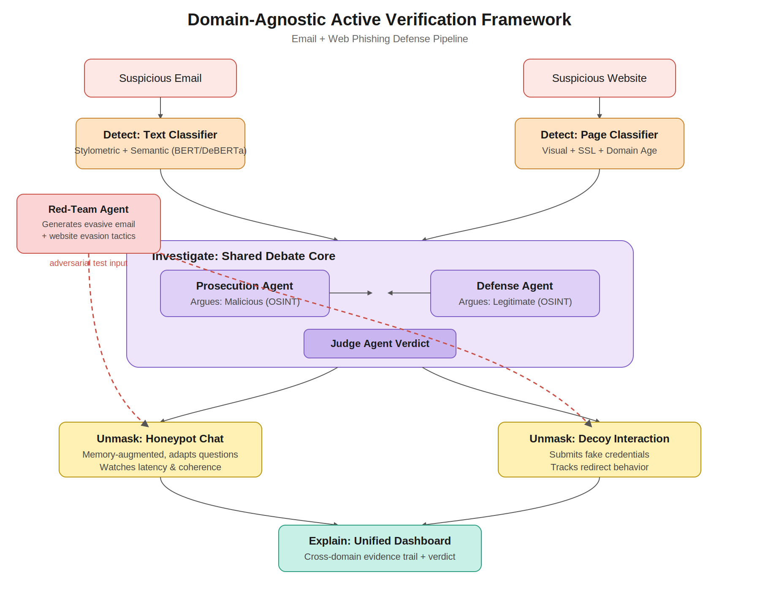
Working:
- Input: The system receives a suspicious email or website.
- Detect:
The email is analyzed using a text-based classifier, while the website is analyzed using visual and structural features such as SSL validity, domain age, and layout similarity.
- Investigate:
The detected suspicious content is passed to a shared multi-agent debate system. The Prosecution Agent looks for evidence indicating malicious behaviour, while the Defense Agent checks evidence supporting legitimacy. A Judge Agent evaluates both sides and produces the verdict.
- Unmask:
The system actively interacts with the suspected source. For emails, a honeypot agent can engage in conversation and analyze response behaviour. For websites, decoy interactions can be used to observe credential handling and redirect behaviour.
- Explain:
The final results, including classifier confidence, OSINT evidence, interaction details, and the verdict, are presented through a unified dashboard for easy analysis and auditing.
- Red-Team Testing:
A red-team agent generates evasive phishing samples to test whether the system can handle changing and adaptive phishing attacks.

